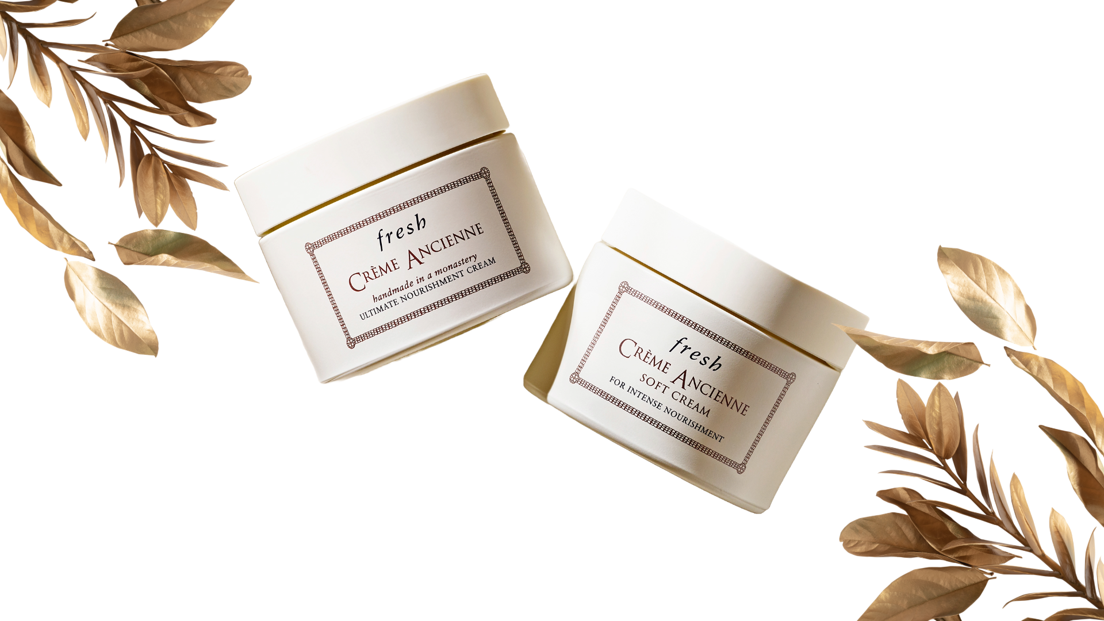Fresh is a renowned skincare brand celebrated for its fusion of natural ingredients, time-honored traditions, and modern innovations, delivering a sensorial and indulgent approach to beauty.

With a commitment to making effective and luxurious skincare products, Fresh has gained attention for its range of products tailored to nourish, revitalize, and restore the skin.

Today, I will be writing about Fresh Creme Ancienne. This moisturizer does so many wonderful things to your skin! Everything you ever wanted to know about the Fresh Creme Ancienne, you will find below!

## **All About The Fresh Creme Ancienne Review**

Fresh Crème Ancienne is a wonderful and effective skincare product that I love! The Creme Ancienne has a rich texture and restorative benefits that make my skin look so fresh.

It helps to smooth the look of fine lines and wrinkles, helps to improve skin stability and deeply nourishes the skin leaving it soft, supple, and radiant!

This cream is designed to leave your skin looking softer, smoother, and feeling refreshed and SO much better than before you used it! Yep, it is that good! This truly is the [best moisturizer](https://www.fresh.com/us/skincare/categories/moisturizers) I have tried in a long time!

My face just looks healthier and those pesky fine lines are looking less noticeable which I love so much! In between getting Botox, I needed the best moisturizer one can buy, and I am pretty sure I found it!

### **Key Benefits of The Product**

Let's look more closely at the key benefits of using Fresh Creme Ancienne every day:

**Visibly Restores Delicate, Fragile Skin**

This product is designed to visibly restore delicate and fragile skin within a timeframe of four weeks. If you are seeking significant improvements in skin texture and appearance in a shorter time, this is the skincare cream to use!

**Improves Skin’s Stability and Smooths Fine Lines and Wrinkles**

The cream is formulated to enhance the skin's stability while effectively smoothing the look of fine lines and wrinkles. This is a great skincare cream for those looking to address signs of aging and improve overall skin texture.

**Intensely Nourishes with a Rich Texture for Youthful Beauty**

Fresh Creme Ancienne boasts a rich and luxurious texture that provides intense nourishment to the skin. This benefits individuals seeking a deeply hydrating and rejuvenating skincare product to maintain youthful and radiant skin.

### **Key Ingredients**

**Meadowfoam Seed Oil**

Meadowfoam is native to the [Pacific Coast in Oregon](https://traveloregon.com/things-to-do/trip-ideas/scenic-drives/the-pacific-coast-scenic-byway/) and is a key ingredient in Fresh Creme Ancienne. Meadowfoam Seed Oil is known for its fatty acid composition that penetrates the top layer of the skin. It is known for its rich softening properties and its ability to intensely nourish skin.

This oil is rich in antioxidants and emollient properties, making it effective in providing deep hydration and locking in moisture.

It helps to improve the skin's stability, which makes it wonderful for restoring and maintaining the skin's natural balance.

**Chamomile Wax**

Chamomile wax is another essential component of Fresh Creme Ancienne, offering soothing and anti-inflammatory properties.

It helps to calm and protect the skin, making it suitable for sensitive and delicate skin types. Chamomile Wax helps to decrease dry spots on your skin, while also softening the skin.

Sometimes my skin can be weird and go through stages and this cream helps by calming down my skin and leaving it so soft and nice feeling.

Each 100g jar contains the equivalent of 1,925 fresh chamomile flowers! Isn’t that awesome?! Chamomile wax also contributes to the cream's luxurious texture, providing a smooth and comforting application experience.

**Beeswax**

Beeswax is a by-product of collected honey and is renowned for its protective and emollient properties. It creates a barrier on the skin to seal in moisture and shield it from environmental stressors.

**Vitamin E**

Vitamin E helps to protect, soothe, and soften the skin.

These key ingredients in the Fresh Creme Ancienne work together to provide a range of benefits for the skin. Meadowfoam seed oil deeply nourishes and improves skin stability, chamomile wax soothes and protects delicate skin, and beeswax creates a protective barrier while sealing in moisture.

### **My Thoughts On Packaging, Scent, And Ingredients**

**Simple Packaging & User-Friendly Container**

Fresh Crème Ancienne comes in nice packaging that reflects the brand's commitment to luxury and quality. The cream is in a jar container, which I appreciate because I don't like the pumps on most skincare products (*they always seem to break!*).

Also, with a jar container, I can easily get ALL the product out and not waste a single drop when it starts getting low. Jar-like containers are the BEST.

**Subtle Relaxing Scent**

The cream has a very delicate and alluring scent (*very subtle wildflowers and chamomile*), that is comforting. I like the lighter fragrance and think it isn't overpowering or '*too muc*h'.

**Natural Ingredients**

The product is crafted with a blend of natural ingredients and features a rich and indulgent texture that glides effortlessly onto your skin, enveloping your skin in nourishment and hydration.

### **Fresh Creme Ancienne Review: How To Use**

In my Fresh Creme Ancienne Review, I will let you know how I use it to get the most benefits out of it. You can follow my process, below!

Here's my step-by-step guide on how to use this restorative face cream:

**1. Only An Almond-Sized Amount:** Begin by getting a medium almond-sized amount of Fresh Creme Ancienne using your fingertips (*make sure your fingers are clean!*). This amount should be sufficient to cover the face and neck area as a little goes a long way!

However, if you do happen to have some leftover, simply wipe it on the backs of your hands! I do this and my hands are so soft now!

**2. Smooth Between Your Fingers:** Gently smooth the cream between your fingers for a second or two, to warm up the cream. This allows the cream to melt and absorb into your skin more easily!

**3. Gently Swipe On Skin:** Use your fingers to gently smooth the cream onto your face (*cheeks, chin, forehead*), and neck area, in a round motion. This will help you to evenly distribute it.

**4. Use with Crème Ancienne Eye Cream:** They do recommend also using their Fresh Creme Ancienne in conjunction with Crème Ancienne Eye Cream.

This combination allows you to address the needs of both your face and delicate eye area for a complete rejuvenating experience!

By following these easy steps, you can be sure that Fresh Creme Ancienne is applied the right way, allowing the cream to do its magic!

### **Frequently Asked Questions**

Still have questions? That is okay! That is why I am including a FAQ section for you with my Fresh Creme Ancienne Review!

**What is restored skin?**

Restored skin refers to a revitalized and rejuvenated complexion that gives you a more youthful, radiant appearance and visibly reduced wrinkles or fine lines. Your restored skin is smoothed and nourished feeling.

**How do Crème Ancienne and Crème Ancienne Soft Cream restore the skin?**

Both Crème Ancienne and Crème Ancienne Soft Cream offer proven multi-dimensional restoration properties, including:

1. Smoothing away the look of fine lines and wrinkles.
2. Improving skin stability to prevent water loss that can contribute to signs of aging.
3. Nourishing the skin with meadowfoam seed oil helps smooth and soften the skin, promoting a more youthful and radiant complexion.

**What's the difference between Crème Ancienne and Crème Ancienne Soft Cream?**

While both creams share the same restorative benefits of smoothing the look of lines, improving stability, and nourishing the skin, Crème Ancienne Soft Cream distinguishes itself with a soft, whipped texture.

This unique texture provides a luxurious and comforting application experience, catering to individuals who prefer a specific creamy consistency.

**Can I use this after a “*dermatological procedure*”?**

A dermatological procedure refers to a professional treatment conducted in-office, targeting specific skin concerns and conditions.

Common procedures include [laser treatments](https://shopwithmemama.com/nira-skincare-laser-helps-reduce-the-signs-of-aging/), IPL *(intense pulsed light)*, ultra-light peels, and tight sculpting, which may cause skin irritation and weaken the skin barrier.

In a clinical study, both Crème Ancienne and Crème Ancienne Soft Cream were tested for four consecutive weeks on 30 panelists of all skin types, including sensitive skin, who underwent non-invasive dermatological procedures.

The results indicated that both creams were suitable for use after such procedures, providing the necessary restoration and nourishment for compromised skin barriers.

So, the short answer is ‘*yes*’, you can use these creams after you have a dermatological procedure!

### **Try It For Yourself!**

You can purchase Crème Ancienne and Crème Ancienne Soft Cream (*or their other wonderful and effective skincare products*) on [their website](https://www.fresh.com/us/home). This creme comes in travel size or full size!

I hope you enjoyed and learned a lot from my review of the product. If you have any other questions, please drop them below and I will answer them if I can. If I can't, I will contact the company for you!